Apply filters to SQL queries

Project description
Potential security issues that involve login attempts and employee machines have been brought up to be investigated. Using SQL filters to retrieve records from the employees and log_in_attempts tables will help recover from these incidents and improve the security posture of the organization.

Retrieve after hours failed login attempts
The log_in_attemps table records all log in attempts and when they were made. The success column indicates whether the login was successful or not using a 1 representing a successful attempt and 0 as a failed attempt.

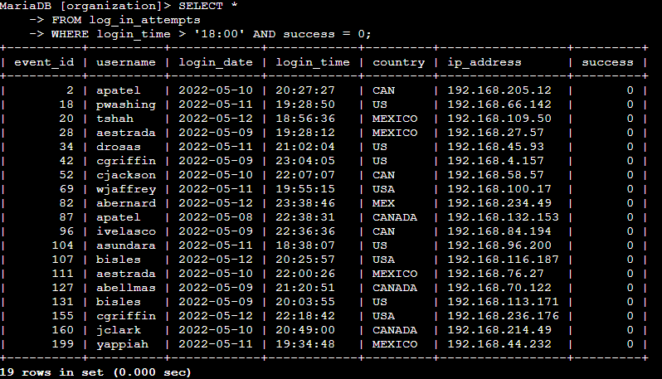

As seen in the screenshot above, I selected all the contents from the log_in_attempts table and used the AND operator to find where the log in attempts failed after 6pm which is after office hours. I found that 19 failed attempts were made after this time.

Retrieve login attempts on specific dates
Next I checked the login attempts on May 8th and 9th of 2022 since a suspicious event occurred on the 9th.The screenshot below shows the query I used to investigate this.

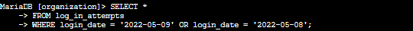

I used the WHERE operator in combination with the OR operator to check the login attempts on both days. The OR operator lets me analyze the attempts on the 8th or the 9th. I found that there were 75 login attempts during the span of both days

Retrieve login attempts outside of Mexico
Investigations by my team were then made to check all login attempts that were made outside of Mexico. I investigated the country column which is shown in the following screenshot.



This query uses the NOT and LIKE operators to search the country column. The NOT operator will filter all results where an argument is not in place. The LIKE operator is used to search for a pattern in a column. In this case the operators were used to find results where the country does not start with the string ‘MEX%’. The % symbol is a substitute for any number of other characters that can proceed. The result of this search was that 144 login attempts were made from outside of Mexico.

Retrieve employees in Marketing
The next task was to research employees using the employees table. Updates to machines have to be made for employees that are in the Marketing department and are located in the East building.
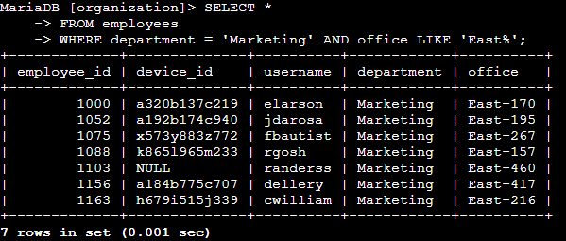

Using a combination of AND and LIKE operations were used to filter out only the employees that match the description. The % symbol was used again to find all offices that started with ‘EAST%’. Doing this gave me all the information of those employees that needed to get updates to their machines. The first employee has the username elarson as seen in the screenshot.

Retrieve employees in Finance or Sales
Another update was due for all the employees in the Finance and Sales departments so a similar query was made to find the correct employees.

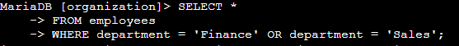

The OR operator was used to search the department column of the employees table to find who needs the required updates to their machines. The username of the first employee found in the Sales department was Irodriqu.

Retrieve all employees not in IT
The final research that was needed was for a final update that was done for the IT department already. Since this is the case, I needed to find all employees from all other departments either then the Information Technology department.

This query uses the NOT operator to filter out all employees that are in the IT department though the department column. The result of this query found that there are 161 employees outside of the IT department that need this update to their machine.

Summary
Combining operators to write SQL queries can help filter through datasets and find important information in order to investigate security issues within an organization. Using simple operators including WHERE, AND, OR, NOT and LIKE, can achieve a lot as shown in this examination and will lead to an improved security posture.

